Question 6 (8 marks)

Let $v=1-\sqrt{3}i$.

(a) Determine the three cube roots of $v$. (3 marks)

(b) Consider the polynomial $P\left(z\right)=z^{4}+2z^{3}+2z^{2}+kz+24$, where $k$ is a real constant.  
  
Given that $P\left(v\right)=0$, solve the equation $P\left(z\right)=0$. (5 marks)

Question 6 (8 marks)

Let $v=1-\sqrt{3}i$.

(a) Determine the three cube roots of $v$. (3 marks)

|  |
| --- |
| Solution |
| $$v=2\operatorname{cis}\left(-\frac{π}{3}\right) \\ v^{\frac{1}{3}}=2^{\frac{1}{3}}\operatorname{cis}\left(-\frac{π}{9}+\frac{2nπ}{3}\right)$$ Hence the cube roots are: $$\sqrt[3]{2}\operatorname{cis}\left(\frac{5π}{9}\right), \sqrt[3]{2}\operatorname{cis}\left(-\frac{π}{9}\right), \sqrt[3]{2}\operatorname{cis}\left(-\frac{7π}{9}\right)$$ |
| Specific behaviours |
| ✓ writes $v$ in polar form  ü obtains one correct root  ü correctly states all roots |

(b) Consider the polynomial $P\left(z\right)=z^{4}+2z^{3}+2z^{2}+kz+24$, where $k$ is a real constant.  
  
Given that $P\left(v\right)=0$, solve the equation $P\left(z\right)=0$. (5 marks)

|  |
| --- |
| Solution |
| $P$ has real coefficients and so $v$ and $\overline{v}$ are factors: $$(z-v)(z-\overline{v})=(z-1+\sqrt{3}i)(z-1-\sqrt{3}i) \\ =z^{2}-2z+4$$ Hence $z^{4}+2z^{3}+2z^{2}+kz+24=\left(z^{2}-2z+4\right)\left(z^{2}+az+6\right)$, where $a$ is a real constant.  Comparing coefficients of $z^{3}$ then $2=a-2⇒a=4$.  Zeros of second quadratic factor: $$z^{2}+4z+6=0 \\ {\left(z+2\right)}^{2}=-2=2i^{2} \\ z=-2±\sqrt{2}i$$ Solutions are $z=1±\sqrt{3}i, =-2±\sqrt{2}i$.  *Note that it is possible to deduce $k=4$, but this is not required.* |
| Specific behaviours |
| ✓ indicates $P\left(\overline{v}\right)=0$ or $z-\overline{v}$ is a factor of $P$ ü correctly determines quadratic factor of  ✓ determines second quadratic factor  ü obtains a zero from second quadratic factor  ü states all solutions |

Question 5 (6 marks)

Let $f\left(z\right)=3z^{3}+pz^{2}+26z+q$, where $p$ and $q$ are real constants.

One of the roots of $f\left(z\right)$ is $z=1+\sqrt{5}i$.

(a) Determine the value of the constant $p$ and the value of the constant $q$. (4 marks)

(b) Show all the roots of $f\left(z\right)$ in the complex plane below. (2 marks)

<EFOFEX>
id:fxd{f8f02ac7-86a6-4f09-8152-b64f5b47a34a}

FXData:

</EFOFEX>

Question 5 (6 marks)

Let , where and $q$ are real constants.

One of the roots of $f\left(z\right)$ is $z=1+\sqrt{5}i$.

(a) Determine the value of the constant $p$ and the value of the constant $q$. (4 marks)

|  |
| --- |
| Solution |
| Product of factors using given root and conjugate: $$\left(z-\left(1+\sqrt{5}i\right)\right)\left(z-\left(1-\sqrt{5}i\right)\right)=z^{2}-2z+6$$ Hence $$f\left(z\right)=3z^{3}+az^{2}+26z+b=\left(z^{2}-2z+6\right)\left(3z+k\right)$$ Comparing $z$ coefficients: $$26=18-2k⇒k=-4$$ Hence from expansion of factors, $p=k-6=-10$ and $q=6k=-24$. $$p=-10, q=-24$$ |
| Specific behaviours |
| ✓ indicates conjugate is another root  ü obtains quadratic factor of $f(x)$ ü uses quadratic factor to obtain linear factor  ü states correct values for $p$ and $q$ |

(b) Show all the roots of $f\left(z\right)$ in the complex plane below. (2 marks)

<EFOFEX>
id:fxd{86550580-e8b8-42eb-b4a5-a2c25d6a3df9}

FXData:

</EFOFEX>

|  |
| --- |
| Solution |
| See diagram |
| Specific behaviours |
| ✓ shows given root and conjugate  ü shows real root |

Question 4 (6 marks)

Consider $f\left(z\right)=z^{4}+kz^{3}+9z^{2}-8z+20$, where $k$ is a real constant.

The equation $f\left(z\right)=0$ has a solution $z=1-2i$.

(a) State a second solution to $f\left(z\right)=0$. (1 mark)

(b) Deduce that $k=-2$. (3 marks)

(c) Determine all other solutions of the equation $f\left(z\right)=0$. (2 marks)

Question 4 (6 marks)

Consider $f\left(z\right)=z^{4}+kz^{3}+9z^{2}-8z+20$, where $k$ is a real constant.

The equation $f\left(z\right)=0$ has a solution $z=1-2i$.

(a) State a second solution to $f\left(z\right)=0$. (1 mark)

|  |
| --- |
| Solution |
| $$z=1+2i$$ |
| Specific behaviours |
| ✓ indicates conjugate root |

(b) Deduce that $k=-2$. (3 marks)

|  |
| --- |
| Solution |
| $$f\left(z\right)=\left(z-1+2i\right)\left(z-1-2i\right)(z^{2}+az+b) \\ =\left(z^{2}-2z+5\right)(z^{2}+az+b)$$ Consider constant term: $20=5b⇒b=4$ Consider $z$ coefficient: $-8=-2b+5a⇒a=0$ Hence $z^{3}$ coefficient $k=\left(1\right)\left(0\right)+\left(-2\right)\left(1\right)⇒k=-2$. |
| Specific behaviours |
| ü factors $f$ into known and unknown quadratics  ü deduces constant term $b$ in quadratic  ü deduces $z$ coefficient $a$ in quadratic and hence value of $k$ |

(c) Determine all other solutions of the equation $f\left(z\right)=0$. (2 marks)

|  |
| --- |
| Solution |
| $$z^{2}+4=0 \\ z=±2i$$ |
| Specific behaviours |
| ✓ factors quadratic  ü states both solutions |

Question 8 (7 marks)

(a) Solve the equation $z^{3}=8\operatorname{cis}\left(\begin{matrix}2π \\ \overline{ 3 }\end{matrix}\right)$, where $-π<\arg{(z)}<0$. (2 marks)

(b) $1, w$ and $w^{2}$ are the three cube roots of unity.

(i) State the value of $1+w+w^{2}$ and the value of $w^{3}$. (1 mark)

Let $u={\left(1+3w+w^{2}\right)}^{2}$ and $v={\left(1+w+3w^{2}\right)}^{2}$.

(ii) Show that $u+v=-4$ and $uv=16$. (4 marks)

Question 8 (7 marks)

(a) Solve the equation $z^{3}=8\operatorname{cis}\left(\begin{matrix}2π \\ \overline{ 3 }\end{matrix}\right)$, where $-π<\arg{(z)}<0$. (2 marks)

|  |
| --- |
| Solution |
| $$z=2\operatorname{cis}\left(\frac{2π}{9}+\frac{2nπ}{3}\right)$$ Hence $$z=2\operatorname{cis}\left(-\frac{4π}{9}\right)$$ |
| Specific behaviours |
| ✓ applies De Moivre's theorem  ü correct root |

(b) $1, w$ and $w^{2}$ are the three cube roots of unity.

(i) State the value of $1+w+w^{2}$ and the value of $w^{3}$. (1 mark)

|  |
| --- |
| Solution |
| Sum of roots: $1+w+w^{2}=0$ Product of roots: $\left(1\right)\left(w\right)\left(w^{2}\right)=w^{3}=1$ |
| Specific behaviours |
| ✓ sum and product |

Let $u={\left(1+3w+w^{2}\right)}^{2}$ and $v={\left(1+w+3w^{2}\right)}^{2}$.

(ii) Show that $u+v=-4$ and $uv=16$. (4 marks)

|  |
| --- |
| Solution |
| $$u={\left(1+w+w^{2}+2w\right)}^{2} \\ ={\left(0+2w\right)}^{2}=4w^{2}$$ $$v=\left(1+w+w^{2}+2w^{2}\right) \\ ={\left(0+2w^{2}\right)}^{2}=4w^{4}=4w$$ Hence $$u+v=4w^{2}+4w \\ =4\left(w^{2}+w+1\right)-4 \\ =-4$$ And $$uv=4w^{2}×4w \\ =16w^{3} \\ =16$$ |
| Specific behaviours |
| ✓ simplifies $u$ ü simplifies $v$ ü derives value for sum  ü derives value for product |

Question 6 (5 marks)

Consider the equation $z^{3}-5z^{2}+15z-18=0, z∈C$.

One root of the equation is $z=3\operatorname{cis}\left(\begin{matrix}π \\ \overline{3}\end{matrix}\right)$.

(a) Solve the equation, giving all solutions in Cartesian form. (4 marks)

(b) Locate all the roots of the equation on the Argand diagram below. (1 mark)

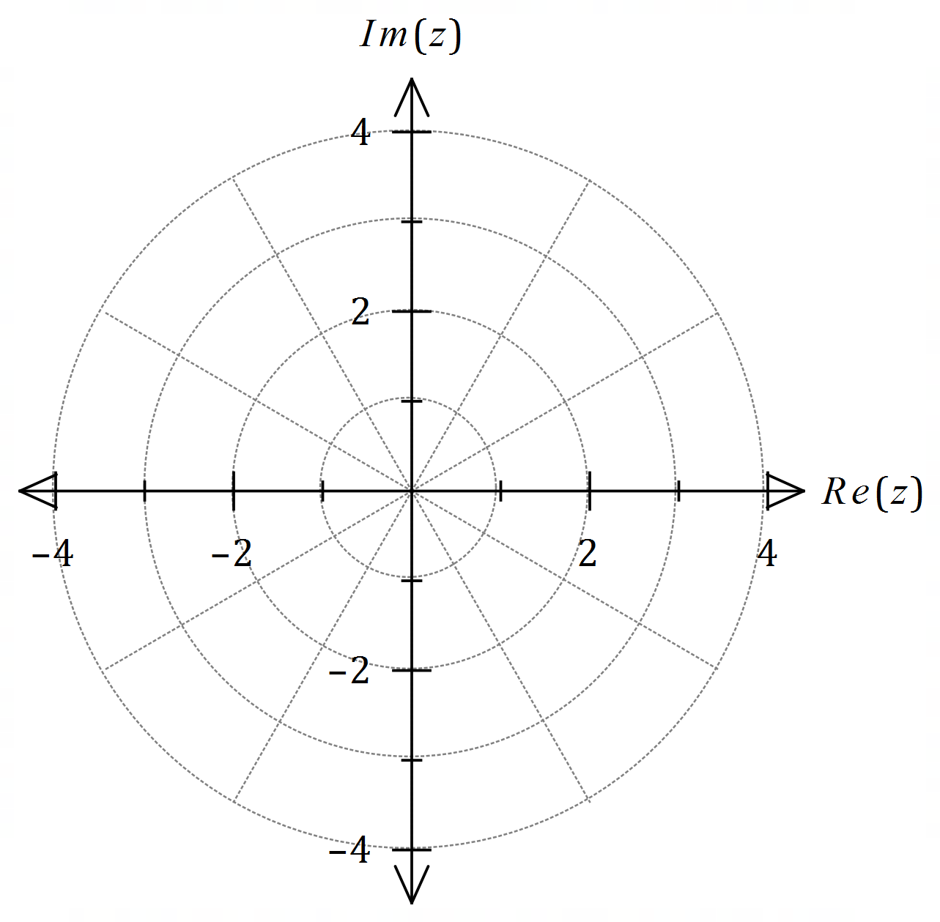

Question 6 (5 marks)

Consider the equation $z^{3}-5z^{2}+15z-18=0, z∈C$.

One root of the equation is $z=3\operatorname{cis}\left(\begin{matrix}π \\ \overline{3}\end{matrix}\right)$.

(a) Solve the equation, giving all solutions in Cartesian form. (4 marks)

|  |
| --- |
| **Solution** |
| Equation has real coefficients - complex roots will occur as conjugate pairs: $$z_{1}=3\operatorname{cis}\left(\frac{π}{3}\right)=\frac{3}{2}\left(1+\sqrt{3}i\right), z_{2}=3\operatorname{cis}\left(-\frac{π}{3}\right)=\frac{3}{2}\left(1-\sqrt{3}i\right)$$ Since the equation must equal $\left(z-z_{1}\right)\left(z-z_{2}\right)\left(z-z_{3}\right)$ then $$\left(-z_{1}\right)\left(-z_{2}\right)\left(-z_{3}\right)=-18$$ But $\left(-z_{1}\right)\left(-z_{2}\right)=z_{1}z_{2}=3\operatorname{cis}\left(\frac{π}{3}\right)×3\operatorname{cis}\left(-\frac{π}{3}\right)=9$ and so $9\left({-z}_{3}\right)=-18⇒z_{3}=2$ Hence solutions are $z=2, \frac{3}{2}\left(1+\sqrt{3}i\right), \frac{3}{2}\left(1-\sqrt{3}i\right)$. |
| **Specific behaviours** |
| ✓ second root in polar form  ✓ expresses both polar roots in Cartesian form  ✓ uses product of roots and $z^{0}$ term  ✓ third solution |

(b) Locate all the roots of the equation on the Argand diagram below. (1 mark)

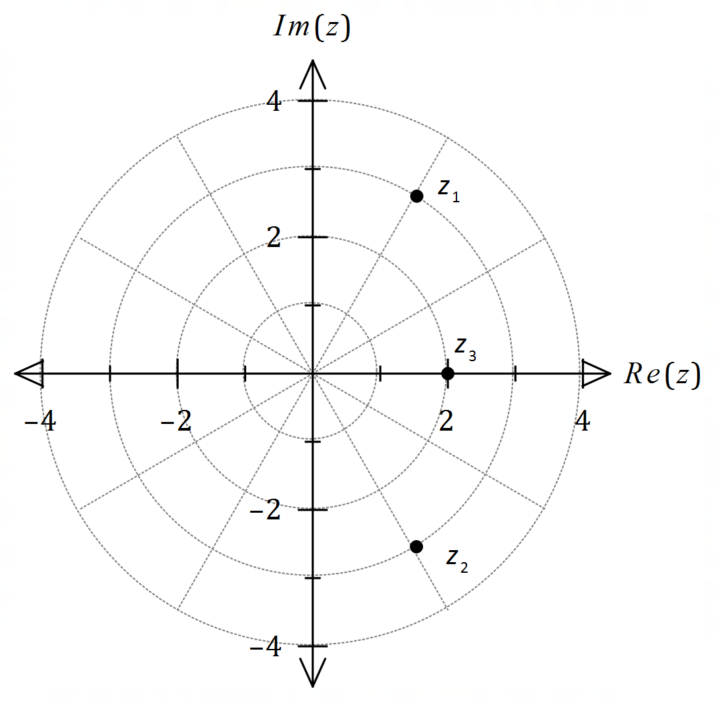

|  |
| --- |
| **Solution** |
| See diagram |
| **Specific behaviours** |
| ✓ correct locations |

Question 2 (6 marks)

Let $u=1-\sqrt{3}i$, $v=2+2i$ and $z=u^{2}v^{3}$.

(a) Determine the modulus and argument of $z$. (4 marks)

(b) Determine the smallest positive integer $k$ such that $z^{k}$ is imaginary. (2 marks)

Question 2 (6 marks)

Let $u=1-\sqrt{3}i$, $v=2+2i$ and $z=u^{2}v^{3}$.

(a) Determine the modulus and argument of $z$. (4 marks)

|  |
| --- |
| **Solution** |
| $u=2\operatorname{cis}\left(-\frac{π}{3}\right)$ and |
| **Specific behaviours** |
| ✓ expresses $u$ and $v$ in polar form  ✓ indicates powers of $u$ and $v$ ✓ forms product  ✓ states modulus and argument |

(b) Determine the smallest positive integer $k$ such that $z^{k}$ is imaginary. (2 marks)

|  |
| --- |
| **Solution** |
| If $z^{k}$ is imaginary, then $\arg\left(z^{k}\right)=\frac{kπ}{12}$ must be even multiple of $\frac{π}{2}$. Hence $k=6$. |
| **Specific behaviours** |
| ✓ indicates argument restriction  ✓ correct value of $k$ |

Question 4 (6 marks)

Let $g\left(z\right)=z^{4}+9z^{2}+14$ where $z∈C$.

(a) Clearly show that $(z-\sqrt{7}i)$ is a factor of $g(z)$. (2 marks)

(b) Solve the equation $g(z)=0$. (4 marks)

Question 4 (6 marks)

Let $g\left(z\right)=z^{4}+9z^{2}+14$ where $z∈C$.

(a) Clearly show that $(z-\sqrt{7}i)$ is a factor of $g(z)$. (2 marks)

|  |
| --- |
| **Solution** |
| $$g\left(\sqrt{7}i\right)={\left(\sqrt{7}i\right)}^{4}+9{\left(\sqrt{7}i\right)}^{2}+14 \\ =49+9\left(-7\right)+14 \\ =63-63 \\ =0$$ |
| **Specific behaviours** |
| ✓ substitutes $z=\sqrt{7}$ correctly  ✓ clearly shows terms sum to $0$ |

(b) Solve the equation $g(z)=0$. (4 marks)

|  |
| --- |
| **Solution** |
| $$g\left(z\right)=\left(z-\sqrt{7}i\right)\left(z+\sqrt{7}i\right)\left(az^{2}+bz+c\right) \\ =\left(z^{2}+7\right)\left(z^{2}+2\right)$$ $$g\left(z\right)=0⇒z=±\sqrt{7}i, z=±\sqrt{2}i$$ |
| **Specific behaviours** |
| ✓ indicates use of conjugate for second factor  ✓ factorises $g(z)$ ✓ obtains third solution  ✓ lists all four solutions |

Question 1 (4 marks)

Consider the equation $4z^{3}-12z^{2}+3z-9=0$.

(a) Show that $z=3$ is a solution of the equation. (1 mark)

(b) Determine $2$ other solutions of the equation. (3 marks)

Question 1 (4 marks)

Consider the equation $4z^{3}-12z^{2}+3z-9=0$.

(a) Show that $z=3$ is a solution of the equation. (1 mark)

|  |
| --- |
| **Solution** |
| $$LHS=4\left(27\right)-12\left(9\right)+3\left(3\right)-9 \\ =108-108+9-9 \\ =0$$ |
| **Specific behaviours** |
| ✓ fully expands each term |

(b) Determine $2$ other solutions of the equation. (3 marks)

|  |
| --- |
| **Solution** |
| $$4z^{3}-12z^{2}+3z-9=\left(z-3\right)\left({4z}^{2}+kz+3\right)$$ $$∴k=0$$ $$z^{2}=-\frac{3}{4}$$ $$z=±\frac{\sqrt{3}i}{2}$$ |
| **Specific behaviours** |
| ✓ factors cubic  ✓ expression for $z^{2}$ ✓ both solutions, simplified |

Question 5 (9 marks)

Let $w=\begin{matrix}1+i \\ \overline{\sqrt{3}-i}\end{matrix}$.

(a) Determine the real constants $a$ and $b$, where $w=a+ib$. (2 marks)

(b) By first expressing $1+i$ and $\sqrt{3}-i$ in polar form, write $w$ in polar form. (3 marks)

(c) Hence determine an exact value for $\cos\left(\begin{matrix}5π \\ \overline{12}\end{matrix}\right)$. (2 marks)

(d) Determine $w^{12}$ in Cartesian form. (2 marks)

Question 5 (9 marks)

Let $w=\begin{matrix}1+i \\ \overline{\sqrt{3}-i}\end{matrix}$.

(a) Determine the real constants $a$ and $b$, where $w=a+ib$. (2 marks)

|  |
| --- |
| **Solution** |
| $$\frac{\left(1+i\right)\left(\sqrt{3}+i\right)}{\left(\sqrt{3}-i\right)\left(\sqrt{3}+i\right)}=\frac{\sqrt{3}-1+i\left(1+\sqrt{3}\right)}{4}$$ $$a=\frac{\sqrt{3}-1}{4}, b=\frac{1+\sqrt{3}}{4}$$ |
| **Specific behaviours** |
| ✓ rationalises  ✓ states values |

(b) By first expressing $1+i$ and $\sqrt{3}-i$ in polar form, write $w$ in polar form. (3 marks)

|  |
| --- |
| **Solution** |
| $$1+i=\sqrt{2}\operatorname{cis}{\frac{π}{4}}, \sqrt{3}-i=2\operatorname{cis}{-\frac{π}{6}}$$ $$w=\frac{\sqrt{2}}{2}\operatorname{cis}{\frac{5π}{12}}$$ |
| **Specific behaviours** |
| ✓ expresses terms in polar form  ✓ modulus of $w$ ✓ argument of $w$ |

(c) Hence determine an exact value for $\cos\left(\begin{matrix}5π \\ \overline{12}\end{matrix}\right)$. (2 marks)

|  |
| --- |
| **Solution** |
| $$\frac{\sqrt{2}}{2}\left(\cos{\frac{5π}{12}}+i\sin{\frac{5π}{12}}\right)=\frac{\sqrt{3}-1+i\left(1+\sqrt{3}\right)}{4}$$ $$\cos{\frac{5π}{12}}=\frac{2}{\sqrt{2}}×\frac{\sqrt{3}-1}{4}=\frac{\sqrt{2}(\sqrt{3}-1)}{4}$$ |
| **Specific behaviours** |
| ✓ equates real parts  ✓ states exact value |

(d) Determine $w^{12}$ in Cartesian form. (2 marks)

|  |
| --- |
| **Solution** |
| $$w^{12}={\left(\frac{\sqrt{2}}{2}\operatorname{cis}{\frac{5π}{12}}\right)}^{12}={\left(\frac{1}{\sqrt{2}}\right)}^{12}\operatorname{cis}\left(5π\right)=-\frac{1}{64}$$ |
| **Specific behaviours** |
| ✓ applies de Moivre's Theorem  ✓ correct value |

Question 7 (7 marks)

On the Argand planes below, sketch the locus of the complex number $z$ given by the following.

(a) $\left|z+1-i\right|=|z-1-3i|$. (3 marks)

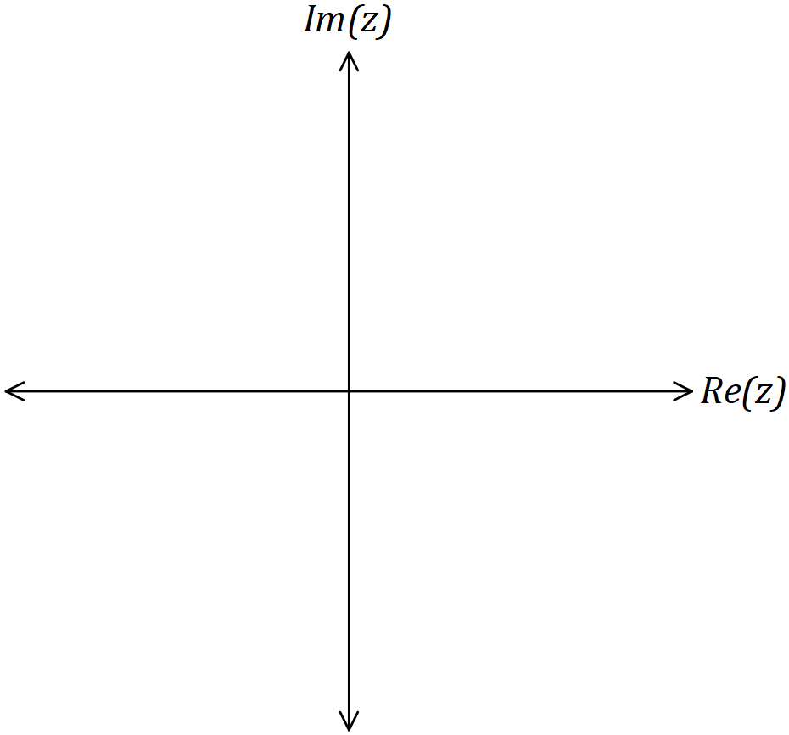

(b) $\begin{matrix}1 \\ \overline{\overset{ }{ z} }\end{matrix}+\begin{matrix}1 \\ \overline{\overset{ __}{ z} }\end{matrix}-\begin{matrix}1 \\ \overline{5}\end{matrix}=0, z≠0$. (4 marks)

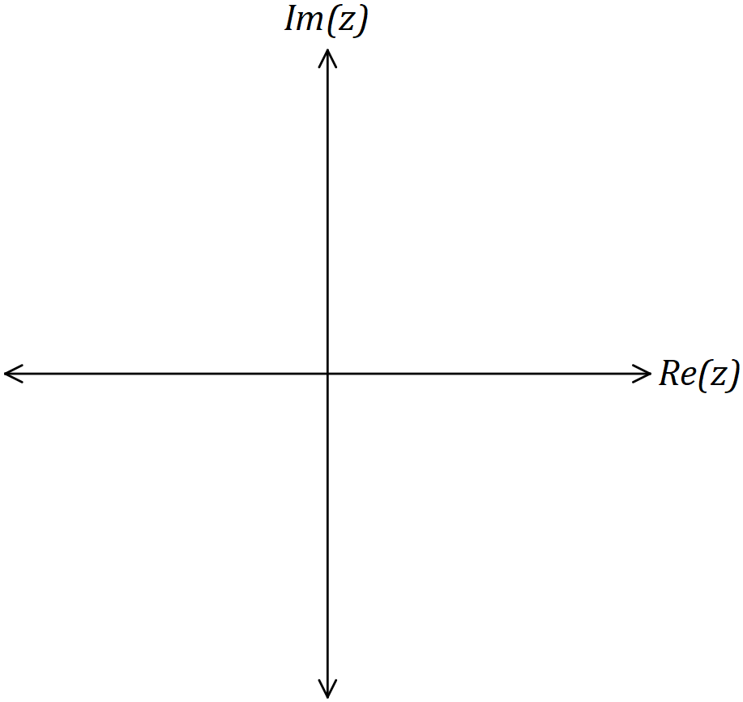

Question 7 (7 marks)

On the Argand planes below, sketch the locus of the complex number $z$ given by the following.

(a) $\left|z+1-i\right|=|z-1-3i|$. (3 marks)

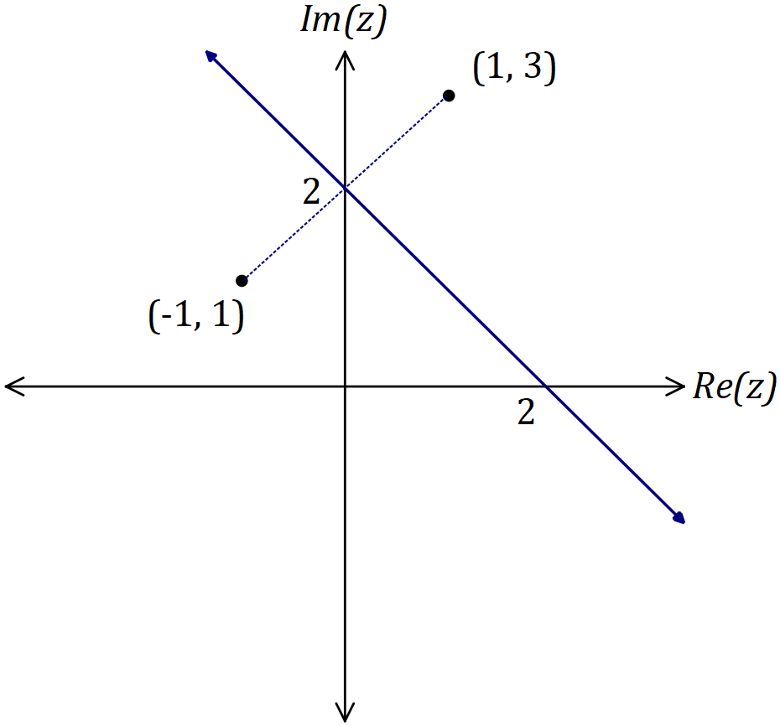

|  |
| --- |
| **Solution** |
| See graph |
| **Specific behaviours** |
| ✓ plots 2 points  ✓ forms perpendicular bisector  ✓ indicates axes intercepts |

(b) $\begin{matrix}1 \\ \overline{\overset{ }{ z} }\end{matrix}+\begin{matrix}1 \\ \overline{\overset{ __}{ z} }\end{matrix}-\begin{matrix}1 \\ \overline{5}\end{matrix}=0, z≠0$. (4 marks)

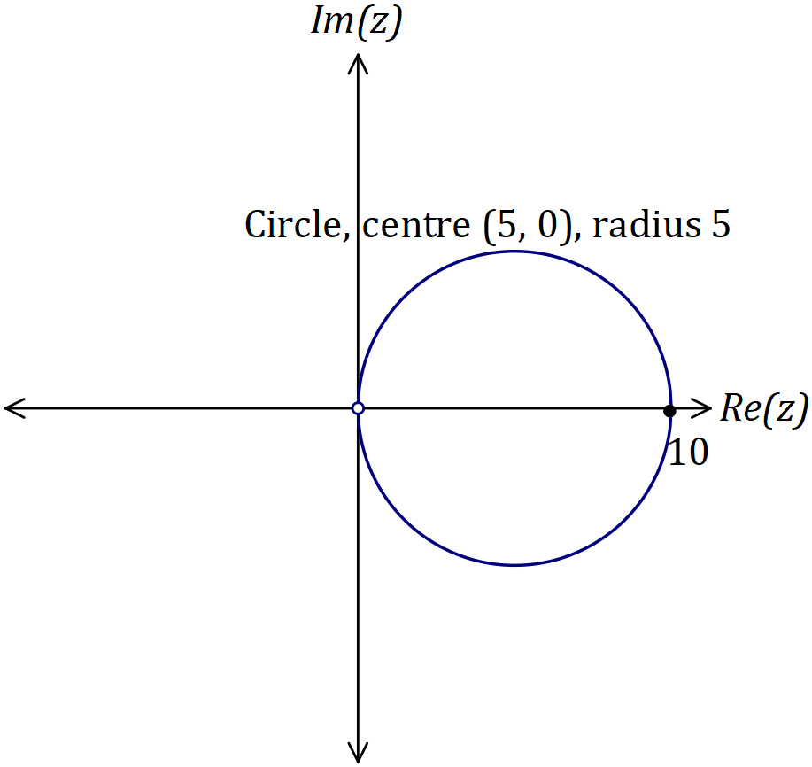

|  |
| --- |
| **Solution** |
| $$\overline{z}+z-\frac{z∙\overline{z}}{5}=0$$ $$z=x+iy⇒10x=x^{2}+y^{2}$$ $${\left(x-5\right)}^{2}+y^{2}=5^{2}$$ See graph |
| **Specific behaviours** |
| ✓ multiplies equation by $z∙\overline{z}$ ✓ simplifies, with $z=x+iy$ ✓ circle with correct centre and radius  ✓ excludes (0, 0) |

Question 1 (7 marks)

(a) Given that $z-2-i$ is a factor of $z^{4}+az^{2}+b$, determine the values of the real constants $a$ and $b$. (4 marks)

(b) Solve the equation $z^{4}+z^{2}-12=0$. (3 marks)

Question 1 (7 marks)

(a) Given that $z-2-i$ is a factor of $z^{4}+az^{2}+b$, determine the values of the real constants $a$ and $b$. (4 marks)

|  |
| --- |
| **Solution** |
| $$\text{Let} z=2+i$$ $$z^{2}=\left(2+i\right)\left(2+i\right)=3+4i$$ $$z^{4}=\left(3+4i\right)\left(3+4i\right)=-7+24i$$ $$-7+24i+3a+4ai+b=0$$ $$\text{Im}\text{:}24+4a=0⇒a=-6$$ $$\text{Re:} -7-18+b=0⇒b=25$$ $$a=-6, b=25$$ |
| **Specific behaviours** |
| ✓ identifies root and substitutes  ✓ determines $z^{4}$ correctly  ✓ equates $\operatorname{Re}{ }$ and $\operatorname{Im}{ }$ parts  ✓ solves for constants |

(b) Solve the equation $z^{4}+z^{2}-12=0$. (3 marks)

|  |
| --- |
| **Solution** |
| $$\left(z^{2}+4\right)\left(z^{2}-3\right)=0$$ $$z=±2i, z=±\sqrt{3}$$ |
| **Specific behaviours** |
| ✓ factorises  ✓ solutions  ✓ solutions |

Question 4 (7 marks)

Let $u=1+\sqrt{3}i$ and $z=-1-i$.

(a) Determine the argument of $u^{4}z$. (3 marks)

(b) Determine the real part of ${(iu)}^{6}$. (4 marks)

Question 4 (7 marks)

Let $u=1+\sqrt{3}i$ and $z=-1-i$.

(a) Determine the argument of $u^{4}z$. (3 marks)

|  |
| --- |
| **Solution** |
| $$\arg{u^{4}}=4×\frac{π}{3}=\frac{4π}{3}$$ $$\arg{z}=-\frac{3π}{4}$$ $$\arg\left(u^{4}z\right)=\frac{4π}{3}+\left(-\frac{3π}{4}\right)=\frac{7π}{12}$$ |
| **Specific behaviours** |
| ✓ indicates $\arg{u^{4}}$ and  ✓ indicates addition of arguments  ✓ states required argument |

(b) Determine the real part of ${(iu)}^{6}$. (4 marks)

|  |
| --- |
| **Solution** |
| $$iu=-\sqrt{3}+i$$ $$=2\operatorname{cis}{\frac{5π}{6}}$$ $${\left(iu\right)}^{6}=2^{6}\operatorname{cis}{π}$$ $$\operatorname{Re}{\text{part}}=-2^{6}=-64$$ |
| **Specific behaviours** |
| ✓ indicates  ✓ expresses $iu$ in polar form  ✓ determines  ✓ states real part |

Question 8 (8 marks)

(a) Determine all solutions to the complex equation $3^{5}z^{5}=2^{4}(-1+\sqrt{3}i)$ in the form $r\operatorname{cis}{θ}$ where $r>0$ and $-π<θ≤π$. (5 marks)

(b) If $w$ is any complex cube root of unity, simplify $(1+w)(1+w^{2})(1+w^{3})$. (3 marks)

Question 8 (8 marks)

(a) Determine all solutions to the complex equation $3^{5}z^{5}=2^{4}(-1+\sqrt{3}i)$ in the form $r\operatorname{cis}{θ}$ where $r>0$ and $-π<θ≤π$. (5 marks)

|  |
| --- |
| **Solution** |
| $$3^{5}z^{5}=2^{5}\operatorname{cis}{\frac{2π}{3}} \\ z^{5}=\left(\frac{2^{5}}{3^{5}}\right)\operatorname{cis}{\frac{2π}{3}} \\ z=\frac{2}{3}\operatorname{cis}\left(\frac{2π}{15}+\frac{k2π}{15}\right), k= -2, -1, 0, 1, 2 \\ z_{1}=\frac{2}{3}\operatorname{cis}{\frac{-2π}{3}} \\ z_{2}=\frac{2}{3}\operatorname{cis}{\frac{-4π}{15}} \\ z_{3}=\frac{2}{3}\operatorname{cis}{\frac{2π}{15}} \\ z_{4}=\frac{2}{3}\operatorname{cis}{\frac{8π}{15}} \\ z_{5}=\frac{2}{3}\operatorname{cis}{\frac{14π}{15}}$$ |
| **Specific behaviours** |
| ✓ expresses $z^{5}$ in polar form  ✓ uses De Moivre's theorem  ✓ expresses general solution in terms of  ✓ states one correct root  ✓ states all five roots correctly |

(b) If $w$ is any complex cube root of unity, simplify $(1+w)(1+w^{2})(1+w^{3})$. (3 marks)

|  |
| --- |
| **Solution** |
| $$w^{3}=1 \text{and} 1+w+w^{2}=0 \text{hence}$$ $$\left(1+w\right)\left(1+w^{2}\right)\left(1+w^{3}\right)=(1+w+w^{2}+w^{3})(2) \\ =2w^{3} \\ =2$$ |
| **Specific behaviours** |
| ✓ uses cube of root  ✓ uses sum of roots  ✓ simplifies |